 | 13.3.5 Editors - Shader Editor - Sidebar - Input and Modify
Table of content
Input and Modify Tab 1
Add Tab 1
Usage 1

Input and Modify Tab
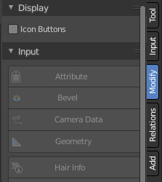
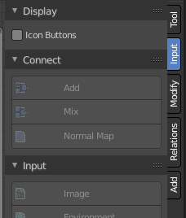
Here you can find the same nodes than in the Add menu. They are a bit different organized to have the most used nodes at the top. And a panel stays open. Which makes the usage of this menu content easier. It's your decision with what system you want to work.
In the Display panel you can adjust if you want to work with icon or text buttons.
We won't explain the content of the panels again. The single nodes are explained in the add menu chapter.

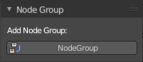
Add Tab
The add tab contains the node groups in the scene once you create them. Note that the Group panel in the Add tab starts empty. It fills dynamically once you create a node group.

Usage
Click at one of the node buttons, then move the mouse into the viewport. The created node sticks at the mouse. Click again to release it.

